Department of Computer Science and Engineering
2025-2026
Odd Semester


DATA STRUCTURES AND ALGORITHMS-3
(25CS2103E)

GENESCAN: DNA SEQUENCE ANALYSIS USING NAVIE STRING MATCHING AND BOYER-MOORE ALGORITHM

- Vaishnavi 2520030198
M. Likhitha 2520030575
AVSNR. Akhila 2520030022

COURSE INSTRUCTOR

Dr. J Sirisha Devi
Professor
Department of Computer Science and Engineering

GENESCAN: DNA SEQUENCE ANALYSIS USING NAIVE STRING MATCHING AND BOYER–MOORE ALGORITHM

Introduction
DNA, or Deoxyribonucleic Acid, contains genetic information in the form of nucleotide sequences. These sequences are represented using four basic nucleotide characters: A (Adenine), C (Cytosine), G (Guanine), and T (Thymine). A DNA sequence can contain thousands or millions of bases, and analyzing such sequences often requires searching for specific patterns or motifs.
GeneScan is a DNA sequence analysis application developed to demonstrate how string matching algorithms from Data Structures and Algorithms can be applied to biological sequence analysis. The primary purpose of the system is to search for a specific DNA pattern, called a motif, within a larger DNA sequence.
The project focuses on two string matching algorithms:
- Naive String Matching
- Boyer–Moore String Matching
The same DNA sequence and the same motif are processed using both algorithms. Their outputs are then compared using measurable parameters such as number of matches, match positions, character comparisons, shifts, and execution time.
The project therefore combines a practical application domain, DNA sequence analysis, with fundamental concepts from string searching algorithms

Problem Statement
Searching for a specific DNA pattern manually is difficult when the sequence becomes large. A DNA sequence may contain hundreds, thousands, or even millions of nucleotide characters. A computational technique is therefore required to locate occurrences of a particular motif efficiently and accurately.
For example, consider the DNA sequence:
ATGCGTACGTAGCTAGCTAGCTAGCTAGCTA
and the motif:
GCTAGCTA
The system has to search the complete DNA sequence and determine:
- Whether the motif exists
- How many times the motif occurs
- The positions at which it occurs
- How many character comparisons are required
- How much time is required for the search
Instead of implementing only one searching method, GeneScan uses two different algorithms so that their behavior can be studied and compared.
This makes the project useful not only as a DNA analysis tool but also as a practical demonstration of how algorithm design affects search performance.

Objectives of the Project

The main objective of GeneScan is to implement and demonstrate DNA pattern searching using two string matching algorithms.
The project aims to:
- Accept a DNA sequence from the user.
- Accept a DNA motif or pattern to search for.
- Support DNA input through direct text and supported document formats.
- Validate and normalize the DNA sequence.
- Implement Naive String Matching from scratch.
- Implement Boyer–Moore String Matching using its searching heuristics.
- Identify all occurrences of the selected motif.
- Record the positions of matching patterns.
- Count the number of character comparisons.
- Measure the execution time of each algorithm.
- Compare the results of Naive and Boyer–Moore.
- Verify that both algorithms produce the same match positions.
- Provide a performance comparison based on the actual input.
- Demonstrate the application of Data Structures and Algorithms concepts in a real-world biological problem.

Algorithms Used
The project implements two algorithms:
- Naive String Matching
- Boyer–Moore String Matching
Both algorithms search for the same DNA motif so their performance can be compared.

System Workflow
DNA Input
↓
Sequence Extraction
↓
DNA Validation and Normalization
↓
Motif / Pattern Input
↓
Select Algorithm
↓
Naive String Matching
OR
Boyer–Moore String Matching
↓
Search Results
↓
Run Remaining Algorithm
↓
Compare Both Algorithms
↓
Performance Analysis

ALGORITHM / PSEUDO CODE

DNA PREPROCESSING

Algorithm: Extract And Validate DNA

Input: Raw text or uploaded file
Output: Valid DNA sequence

1. Read the input.
2. If the input is a file:
a. Detect the file type.
b. Extract its text.
3. Identify the meaningful DNA sequence.
4. Remove unnecessary whitespace.
5. Convert the sequence to uppercase.
6. Ignore FASTA headers beginning with '>'.
7. Check every character.
8. If a character is not A, C, G or T:
report invalid DNA input.
- Return the validated DNA sequence.

Algorithm: NaiveSearch

Input:
Text T of length n
Pattern P of length m
Output:
Match positions
Number of comparisons
Execution time

1. Initialize an empty list of match positions.
2. Set comparisons = 0.
3. Start execution timer.
4. For i = 0 to n - m:
a. Set j = 0.
b. While j < m:
i. Increment comparisons.
ii. Compare T[i+j] with P[j].
iii. If they are different:
break.
iv. Otherwise increment j.
c. If j == m:
store i as a match position.
5. Stop execution timer.
6. Return all match positions,
comparisons and execution time.
Algorithm: Boyer- Moore
Build_Bad_Character_Table

Input:
Pattern P of length m
Output:
Bad Character Table
1. Initialize every character's last occurrence as -1.
2. For i = 0 to m - 1:
Set LastOccurrence[P[i]] = i.
- Return LastOccurrence table.

Algorithm: Build_Good_Suffix_Table
Input:
Pattern P of length m
Output:
Good Suffix Shift Table

1. Initialize the shift table.
2. Identify suffixes of the pattern.
3. Find matching suffix occurrences within the pattern.
4. Calculate the safe shift for each mismatch position.
5. If a matching suffix is not available,
use the appropriate fallback shift.
6. Return the Good Suffix table.
Algorithm: Boyer_Moore_Search

Input:
DNA sequence T of length n
Pattern P of length m
Output:
Match positions
Number of comparisons
Number of shifts
Execution time

1. Build the Bad Character table.
2. Build the Good Suffix table.
3. Set shift = 0.
4. Initialize MatchPositions.
5. Set comparisons = 0.
6. Set shifts = 0.
7. Start execution timer.

8. While shift <= n - m:
a. Set j = m - 1.
b. Compare the pattern with the DNA
from right to left.
c. While j >= 0 and P[j] == T[shift + j]:
comparisons = comparisons + 1
j = j - 1

d. If j < 0:
A complete match is found.
Add shift to MatchPositions.
Calculate the next safe shift.
e. Else:
comparisons = comparisons + 1
Calculate Bad Character shift.
Calculate Good Suffix shift.
Choose the larger valid shift.
f. Update shift.
g. shifts = shifts + 1.
9. Stop the execution timer.
10. Return:
Match Positions
comparisons
shifts
execution time
RESULTS

Screenshots:

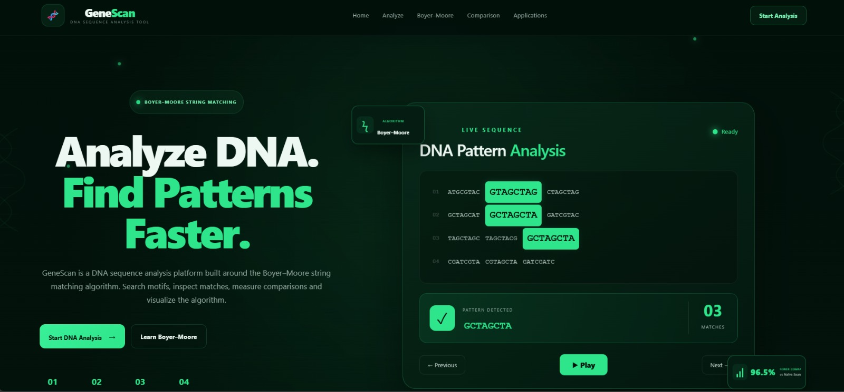
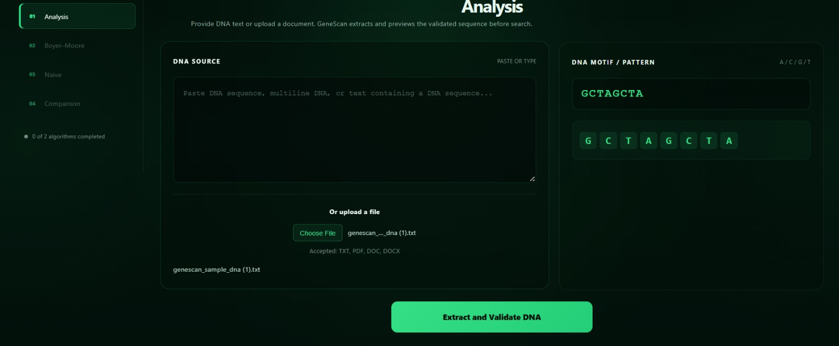
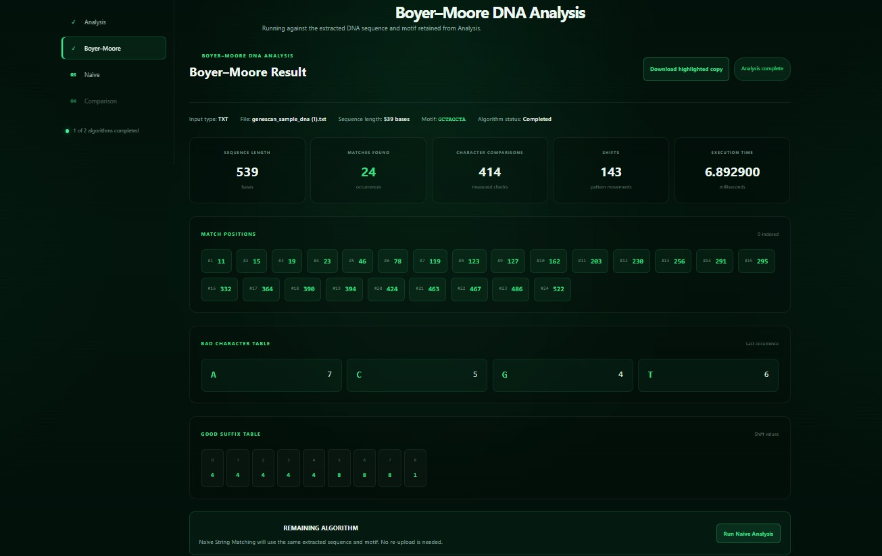
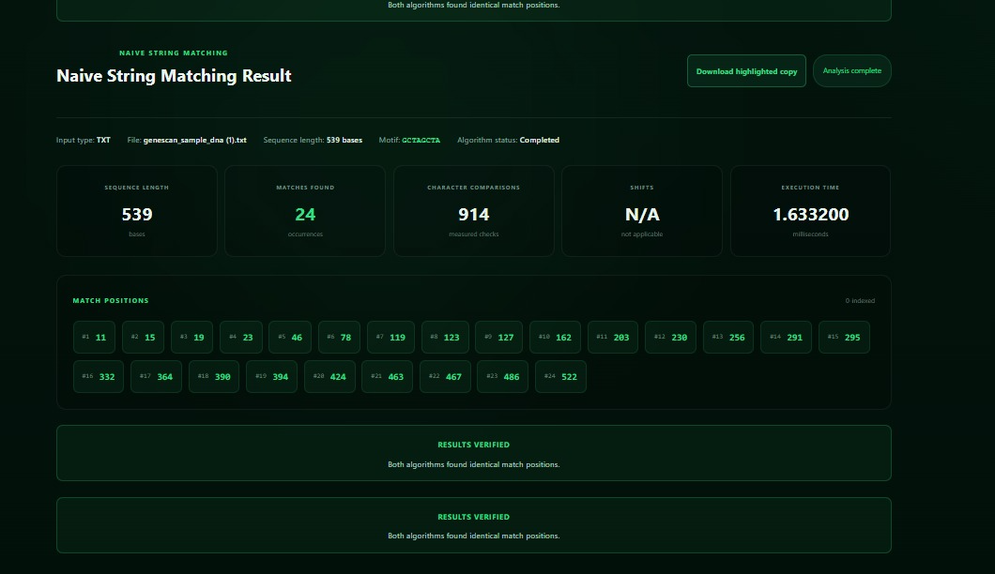
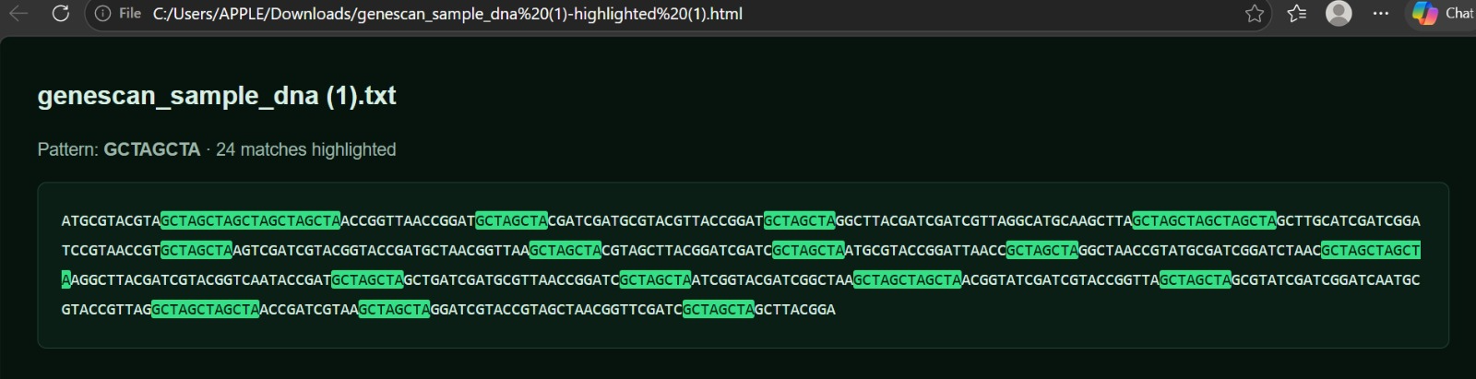S

